Formation of textile factories |  | Difficulty
Formation of textile factories |  |  | 1

Name︰_______________ （ ） Class︰__________

Historical skill | Interpret paintings, comparing similarities and differences
Related Textbook Content | 2A pp. 48, 56

Study the sources below and answer the following questions.

Source A Painting depicting British workers working at home before the Industrial Revolution
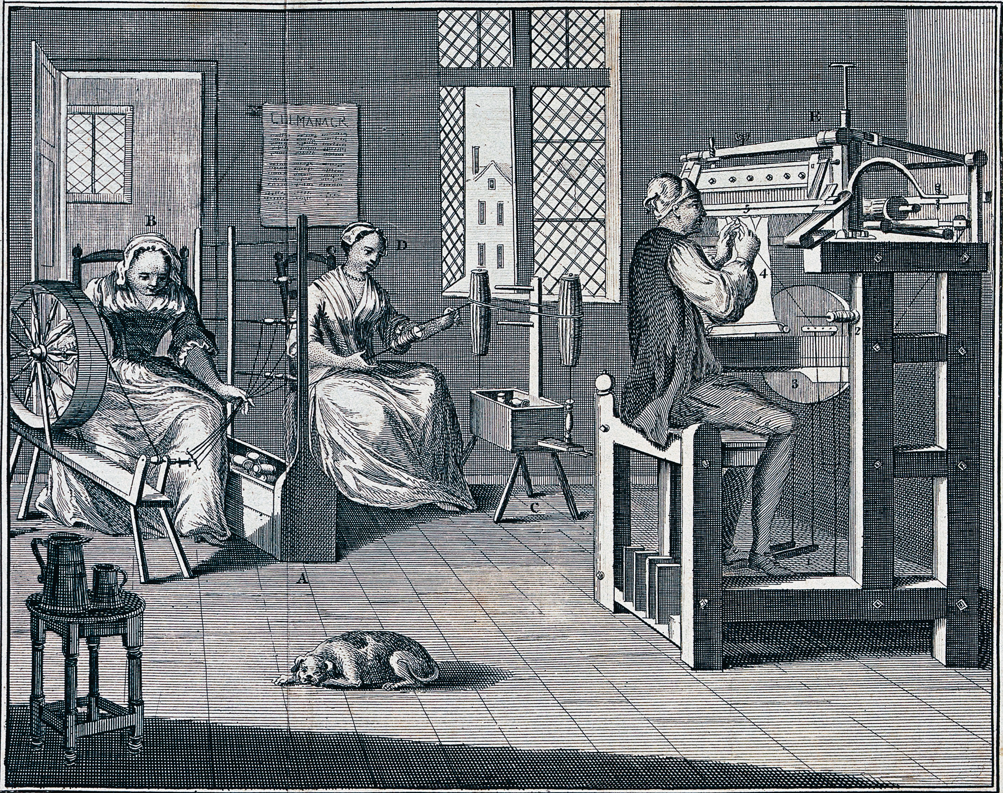

Source B Painting depicting the production process in a British factory during the Industrial Revolution
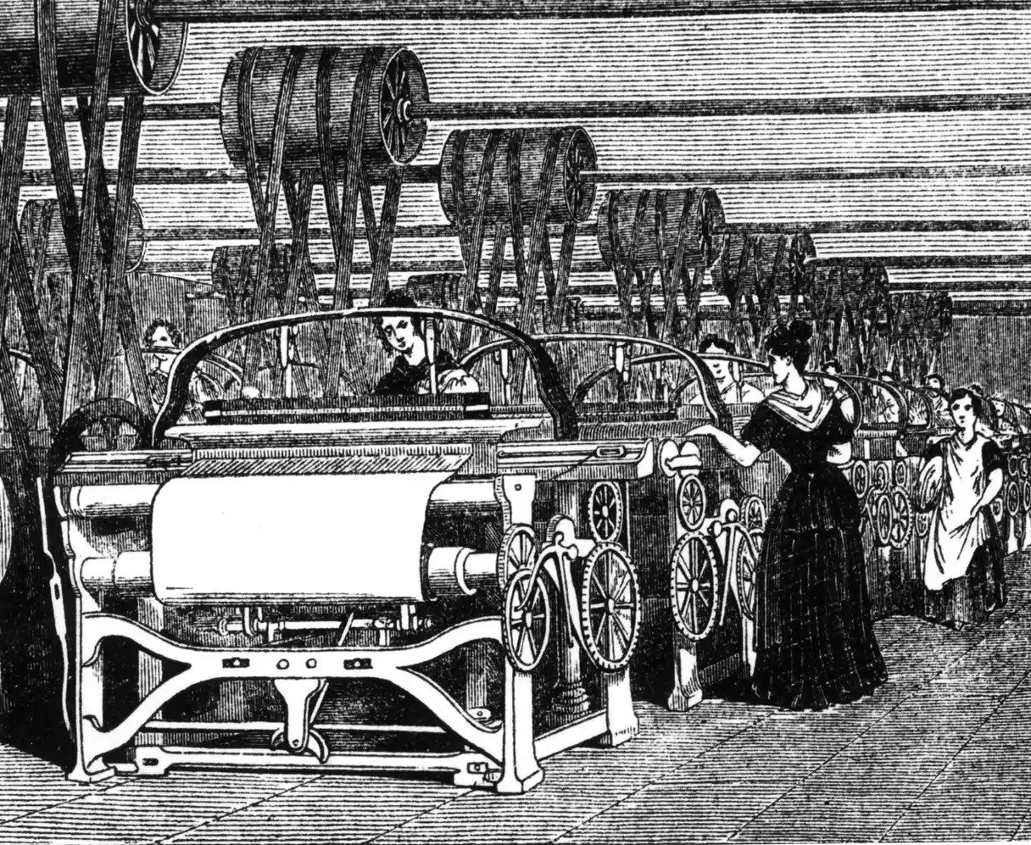
1. Source A and B reflected the production process of which industry? Observe source
______________________________________________________________________

2. What were the differences between working environments depicted in Source A and B? Explain your answers. Compare similarities and differences
The workers in Source A were working in _______________, each person were responsible for [ one ／ many] machine; Source B depicted workers working in _______________, with more than one person responsible for the same position.

3. In what ways did the Industrial Revolution improve the efficiency of manufacturing products? Explain your answer with reference to the sources above. Analyse source
The Industrial Revolution encouraged the _______________ of industries, resulting in a rise in the productivity of goods. Source B shows that after the Industrial Revolution, Britishs started using _______________ to create textiles. Workers could produce [ few ／ many ] goods collectively. In comparison of that, before the _______________, Source A shows the working system that could only produce [ few ／ mnay] goods. Producitvity was comparatively slow.

Answers

1. Textile industry.

2. The workers in Source A were working in ______home_____, each person were responsible for [ one ／ many] machine; Source B depicted workers working in ______factory_____, with more than one person responsible for the same position.

3. The Industrial Revolution encouraged the _____mechanisation_____ of industries, resulting in a rise in the productivity of goods. Source B shows that after the Industrial Revolution, Britishs started using ______large machines_____ to create textiles. Workers could produce [ few ／ many] goods collectively. In comparison of that, before the ______Industrial Revolution_____, Source A shows the working system that could only produce [ few ／ many] goods. Producitvity was comparatively slow.

